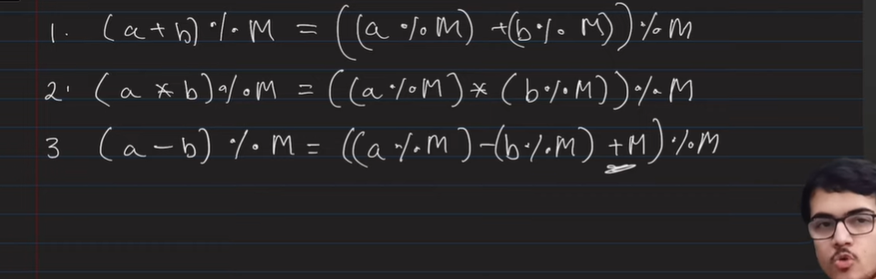

Here in +M we do in subtraction to avoid Negative values and also it does not add affect because M%M is zero

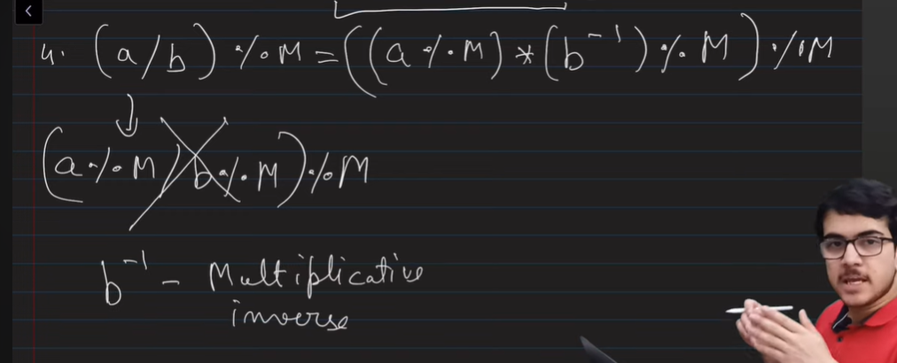

Finding prime numbers so that multiplied upto number, start I=2 and then upto n

And inserting I and keep dividing n by I.

I<=n also work and i\*i<=n but with condition that if n>1 then push it in container too

